Spring CLI

Spring Command Line Interface

Create a project of archetype “quickstart”:

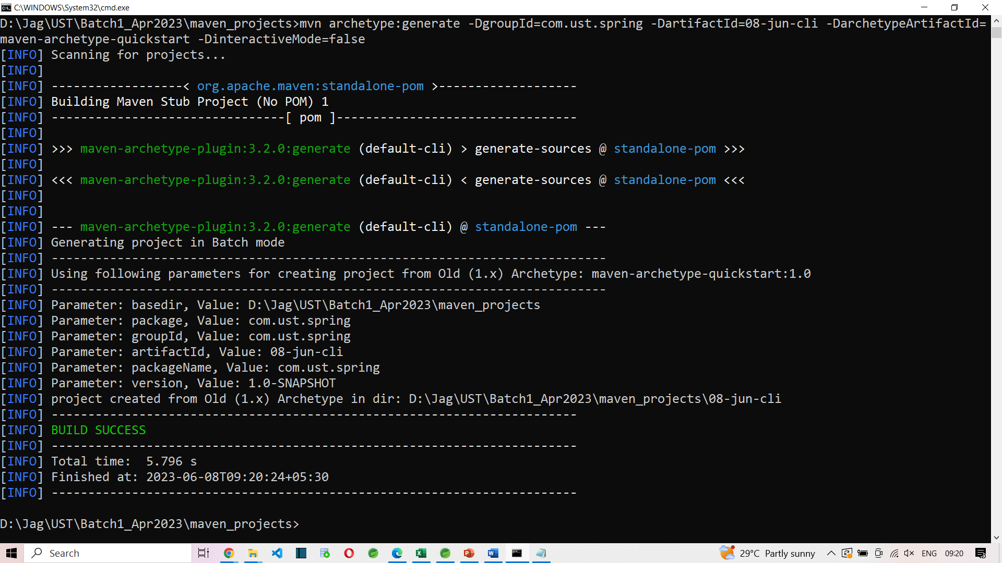

To run a spring boot application from command line (maven project)

mvn spring-boot:run

this command must be run in a location where pom.xml is present.